Lakota Language Online Assessment

You will need:
- Computer with internet connect
- Headphones

Directions:
- Go to: www.languageconservance.org/new_test/
- Click on Student Login

- Select Language: Lakota
- Select Level: Level 1 (You will take ALL FOUR tests)
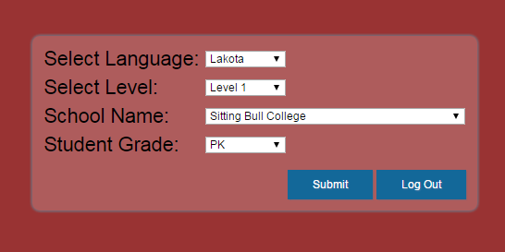
- School Name: Sitting Bull College
- Student Grade: PK

- Submit
- Take Test
- Fill in First Name, Last Name, Date of Birth, and Email (optional)
- Take test.

Other Notes:
You must complete ALL FOUR tests, each test will increase in difficulty.
As you fill in your information for the following tests, a textbox will appear asking you to update your information, select yes/update, as this will link your tests together!
Tests must be taken by SEPTEMBER 25, 2015!

